MGMS – Account head wise allocation

Functional Specification Document

Ver. 1.4

Version History
Date | Description
11-Oct-2010 | First draft

Table of Contents

Version History 2
1 Introduction 4
1.1 Purpose 4
1.2 Scope 4
1.3 Assumptions 4
1.4 Constraints 5
2 Head wise allocation 5
3 Business Rules 9
4 Status Messages 9

Introduction

Purpose

This document provides the requirements and functional specifications for the feature enabling account head wise allocation of funds in the Multisite Grant Management System project.
This is not a project plan or a design document. It is a guide for system architecture and development, not for phasing, timelines or deliverables.
Finally, this is a ‘living document’ and the specification will change, continuously, as the project proceeds. More details will be added and the existing information edited as the requirements, scenarios and use cases evolve in the course of the project.

Scope

Account Heads are created for convenient management of financial transactions and their reporting. At present, 2-levels of account heads can be created – account heads and sub account heads.
- The institution can divide the allocation for a project to different account heads and sub-account heads.
- This will be done against a grant period and displayed as a pie chart in the MGMS application
- For each allocation to an account head, the details saved are – grant period, account head name, sub-account head name, the amount and any description by the user.
- Editing/updating is possible any number of times
Currently the grantee records the details of the allocation as part of the financial transactions. Future scope includes validation to be set according to the grant details recorded.

Assumptions

The grant entails disbursing of the entire amount amongst the account heads only. This would mean that the transactions such as expenses, asset purchase etc cannot be associated with the amount that are not yet allocated to any account head. Only fund transfer to sub awardees can be done.

Constraints

There is a definite dependency on the grant award module that is still under development. So there will be definite logical connection between the award details recorded and the allocations made in the financial sections.
Further requirements needed as to the level of control of grantor over the allocation to grantee account heads -

Head wise allocation

This deals with allotting portions of the project’s grant allocation to various account heads associated with the project. Currently allotment may be done to sub –account head level also. An example:
An institution is awarded a grant of Rs 10 Lakhs for undertaking Project over 3 years. Now, the first allocation is for Rs.4 Lakh during the first year. The institution can further allocate in the following manner.
Allocate Rs 1 L to the IT account head
Allocate Rs 2 L to the sub account head Payroll (which is a sub account head of account head HR.)
And so on…
Using the Master module, any number of account heads and sub accounts may be created for the institution and further, associated with each of its projects.

Screen & Control Description

Figure 1: Disburse fund against account heads
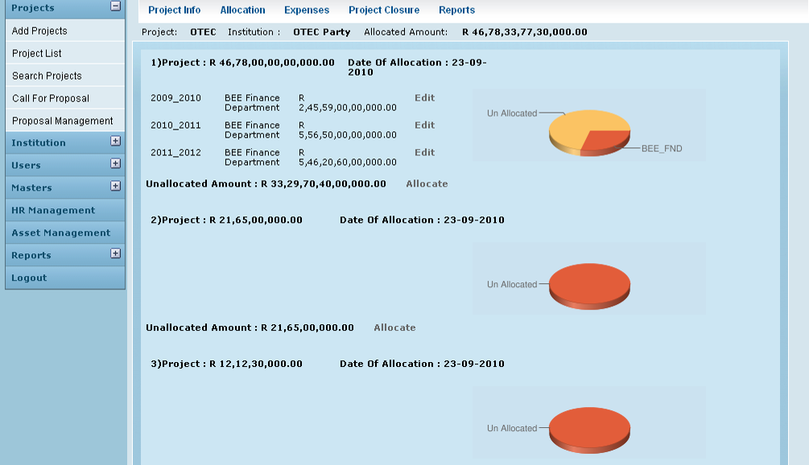

Field /Label | Input-Control | Data Type | Details
Project: | Auto populated | String
Institution: | Auto populated | String
Allocated Amount: | Auto populated | Number
<Sl No> | Auto increment - populated
Project: |  | String
<allocated amount> | Auto populated | Number
Date of Allocation: | Auto populated | Date
<grant_period> | Auto populated
<sub account head name> | Auto populated | String
<amount_allocated to subaccount head> | Auto populated | Number
Edit | Button
Unallocated Amount: | Auto populated | Calculated | Formula = (allocated amount) – (amount allocated to sub account heads associated with the project). (2 fields above)
Allocate | Button

Graphical Representation

For each grant allocation to the project, a pie chart displays the account head allocations and the remaining unallocated amount.

Google chart tool is being used here.

Chart Component | Value/Requirement | Details
Chart type | 3D pie chart
Chart size (width x height) | 300 x 95 pixels
Chart color (slices) | e25d3a,fb363
Chart background fill solid color | cbe2f 0
Chart area gradient fill at angle 45’ color | cbe2f 0  color centre point is 0  cbe2f 0  color centre point is 1
Chart Title | Fund Allocation
Chart title color, font size | 0000ff,1
Chart data | amounts allocated to different account heads | grant_allocation_split>amount;  (grant_allocation>amount_allocated)-(sum of all grant_allocation_split>amount) should be a data and labeled as “unallocated” amount
Slice Labels | account head names | account_heads>name
Legend position | Legend to the right of the chart, legend entries in a vertical column.

Edit

Figure 2: Edit Head Allocation
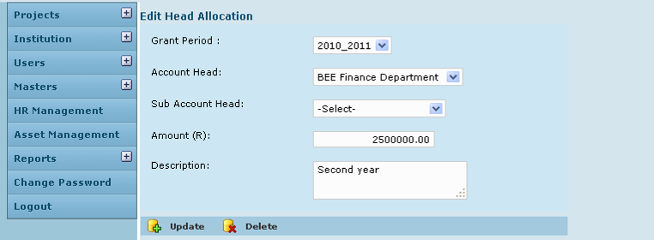

Field /Label | Input-Control | Data Type |  | Details
Edit Head Allocation
Grant Period: | Auto populated but editable Listbox |  | String
Account Head: | Auto populated but editable Listbox |  | String
Sub account head: | Auto populated but editable |  | String
Amount: | Auto populated but editable Textbox |  | Number
Description: | Auto populated but editable Textarea |  | String
Update | Button |  |  | On clicking, same screen refreshes with message – Head allocation updated successfully
Delete | Button |  |  | The entry deleted

Allocate

Figure 3: Add more heads
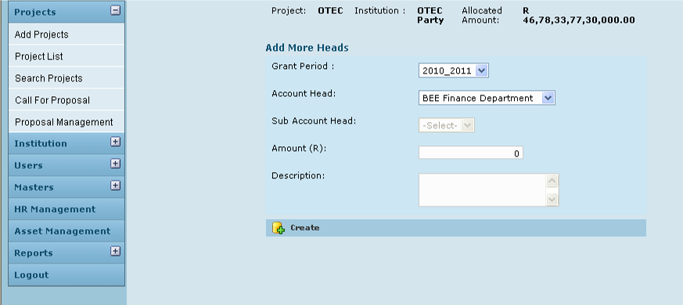

Field /Label | Input-Control | Data Type | Details
Project: | Auto populated | String
Institution: | Auto populated | String
Allocated Amount: | Auto populated | Number
Add more heads
Grant Period: | Listbox | String
Account Head: | Listbox | String
Sub Account Head | Disabled listbox | String
Amount (R) | Textbox | Number
Description | Textarea | String
Create | Button |  | The record is saved

Business Rules
The major validations required are:
- Sum of all sub account head allocations should not be more than the allocation for the particular account head
- Sum of all account head allocations should not be more than the grant allocations for the project.
Multiple allocations may be made to the same account head or sub account head from the same grant.

Status Messages

Sl No | Status Message
1 | Created Successfully
2 | Updated Successfully
3 | Deleted Successfully
4 | The Requested Record Not Found
5 | The Record can't be deleted, Already in use
6 | The Record Already Exists
7 | Please Enter a valid email address
8 | You can not delete yourself, please login as another admin and try again
9 | Cannot delete the Head wise Allocation as Grant Expense is entered
10 | Cannot delete the Head wise Allocation as Grant is Received
11 | Grant Head Deleted
12 | Grant can not Allocated to Heads
13 | Grant is Allocated to Heads
14 | Grant Allocation

